1)Install git.

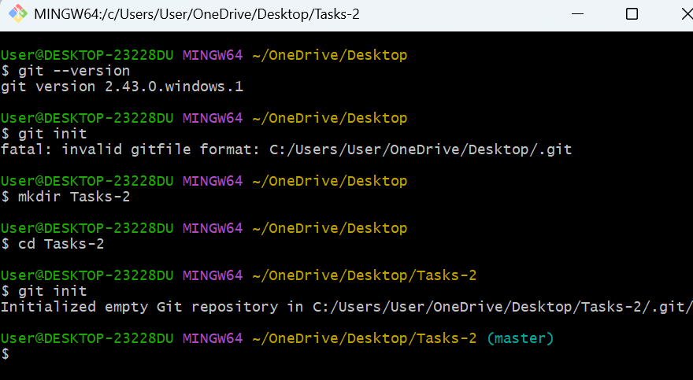

2)Create a repo in github with README.md and .ignore file.

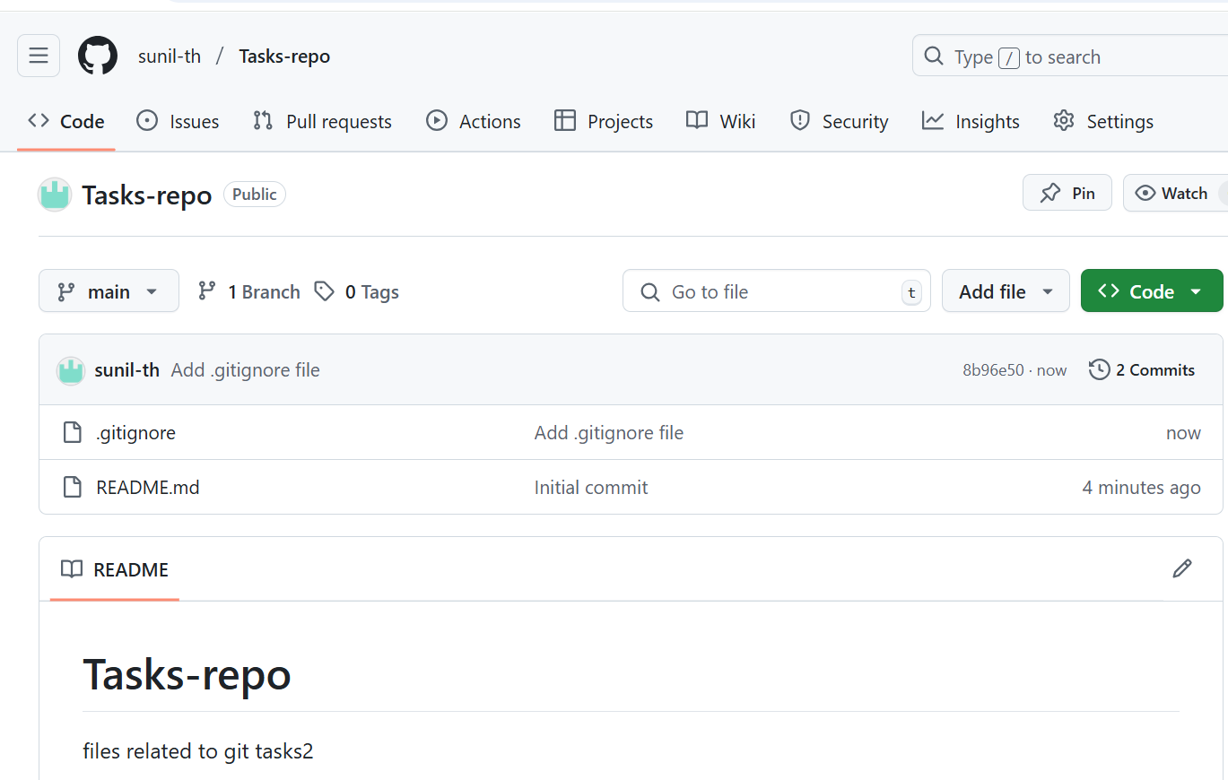

3)Clone the created repo to local.

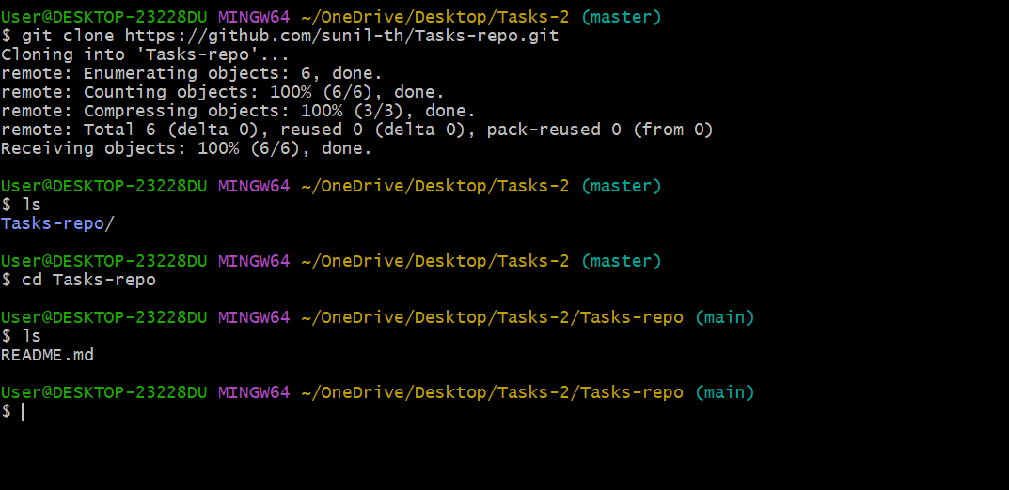

4)Create two files in local repo.

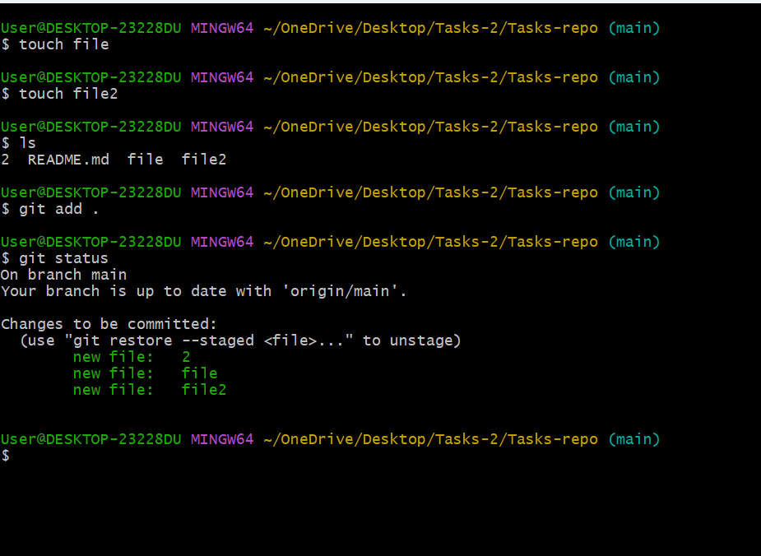

5)Commit two files and push to central Repository.

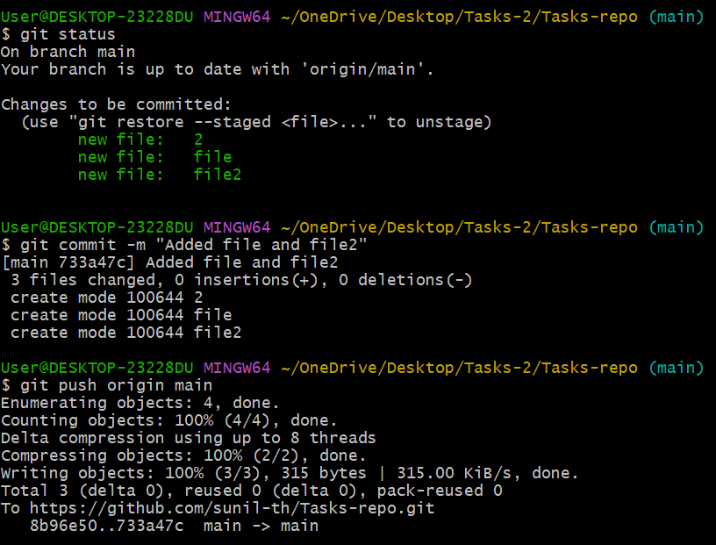

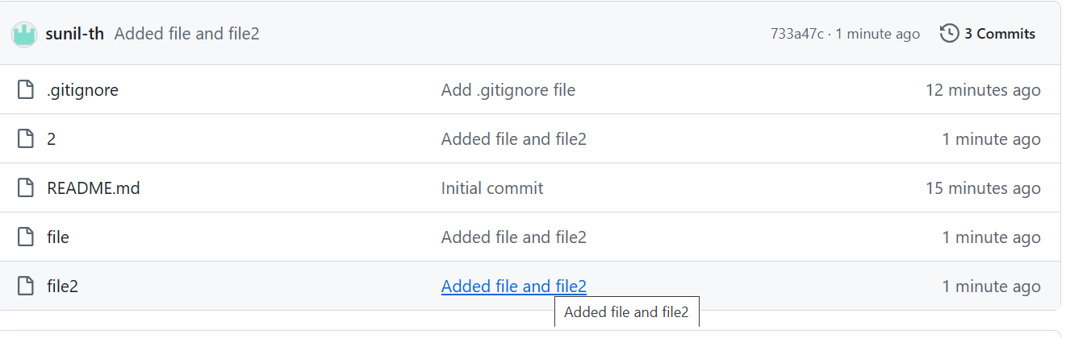

6)Create a branch in local and create a sample file and push to central.

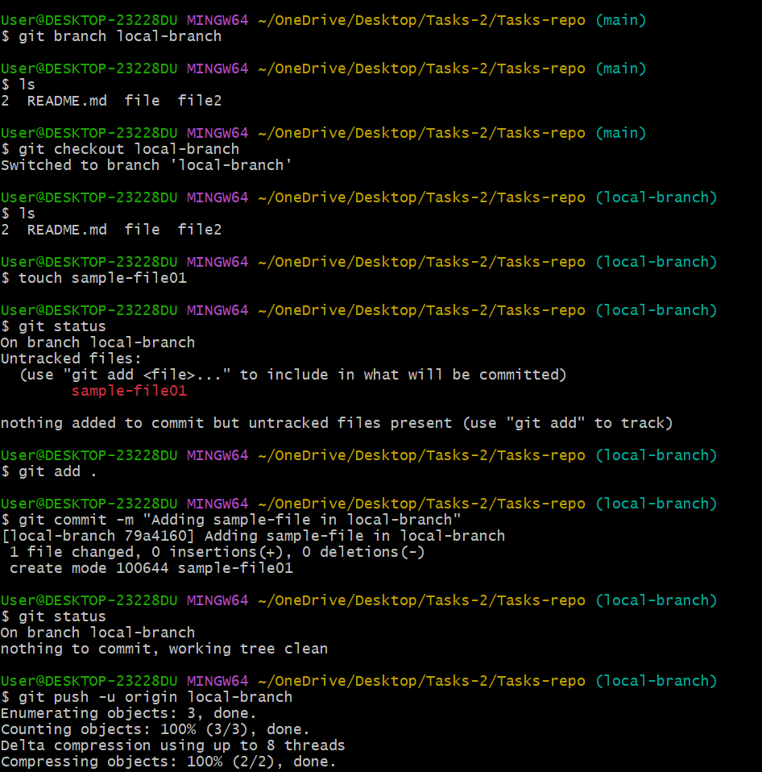

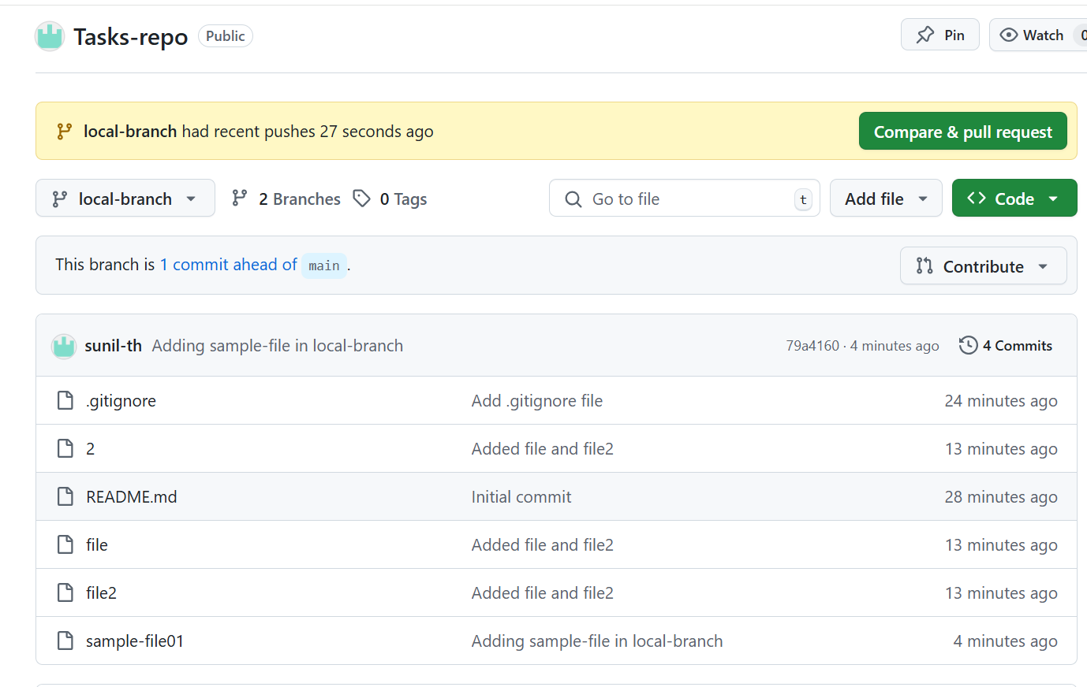

7)Create a branch in github and clone that to local.

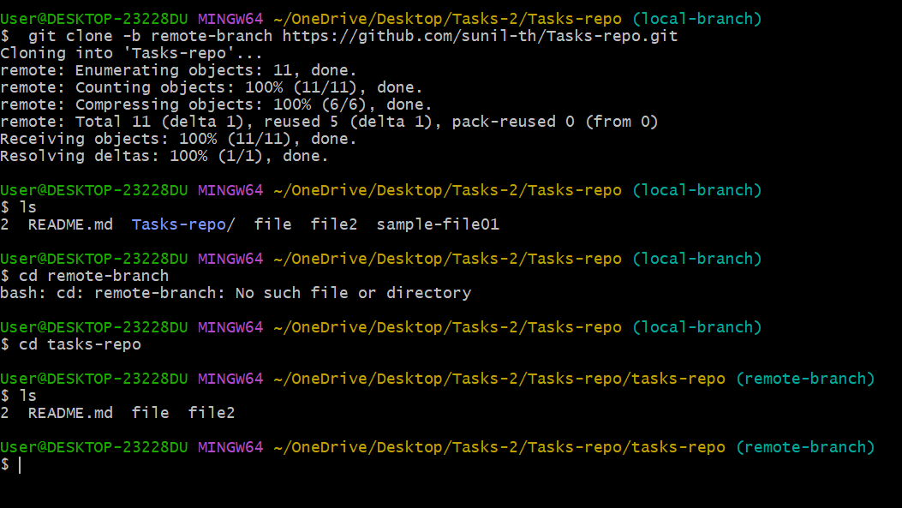

8)Merge the created branch with master in git local.

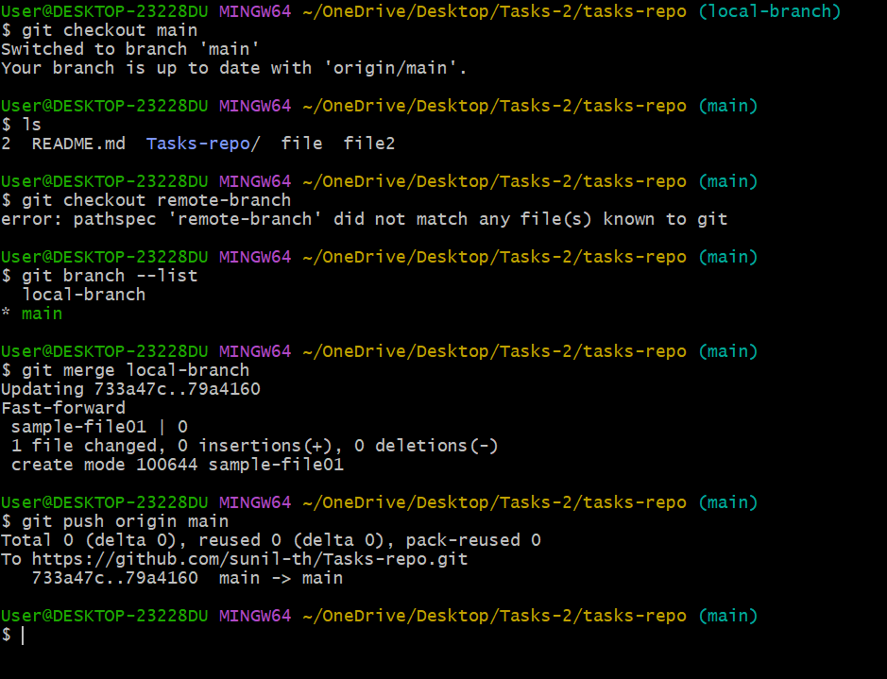

9)Merge the created branch with master in github by sending a pull request.

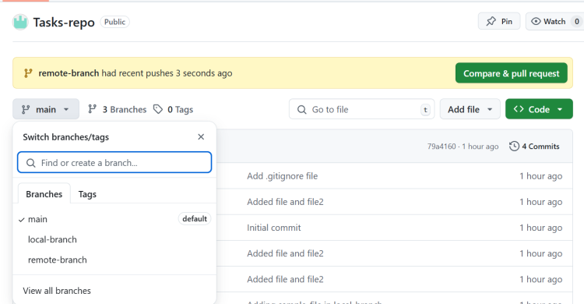

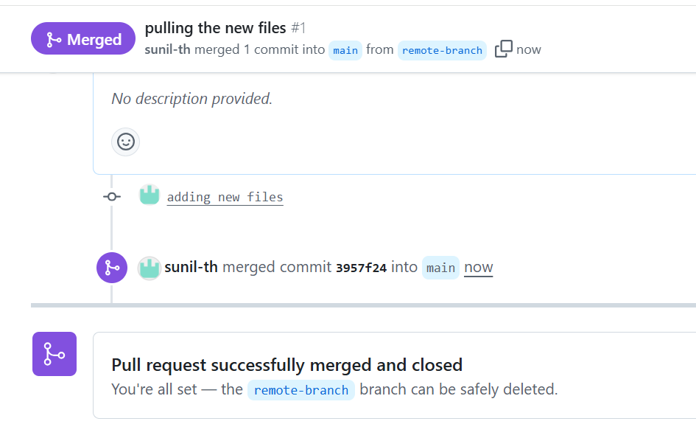

10)create a file in local and send that to branch in github.

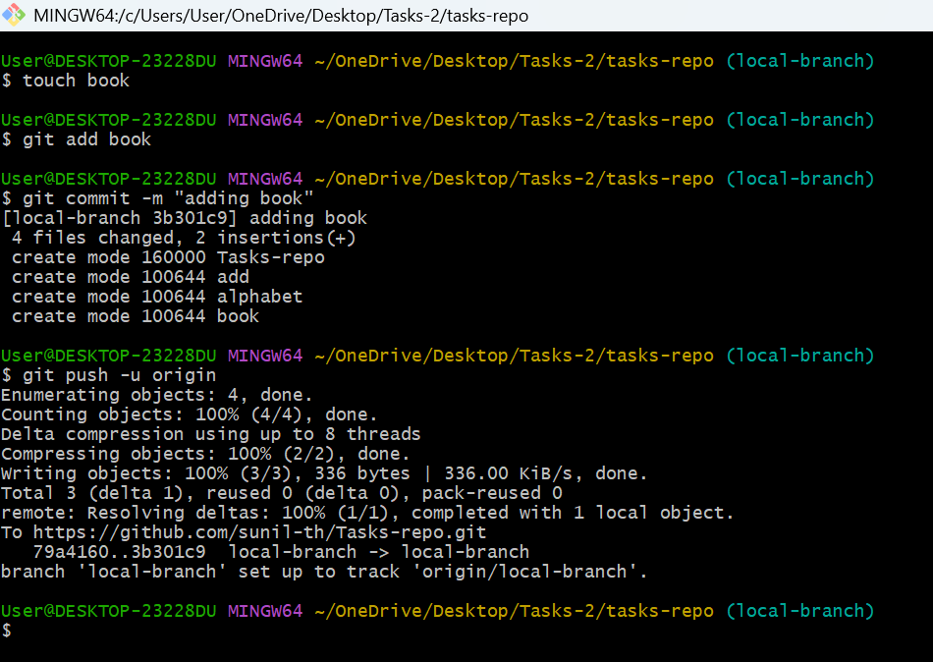

11)clone only a branch from github to local.

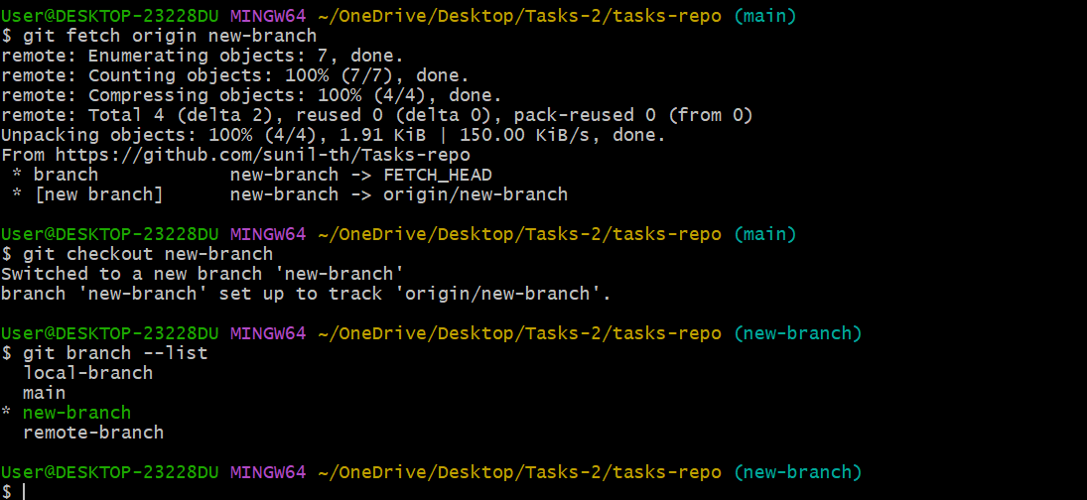

12)create a file with all passwords and make that untrackable with git.

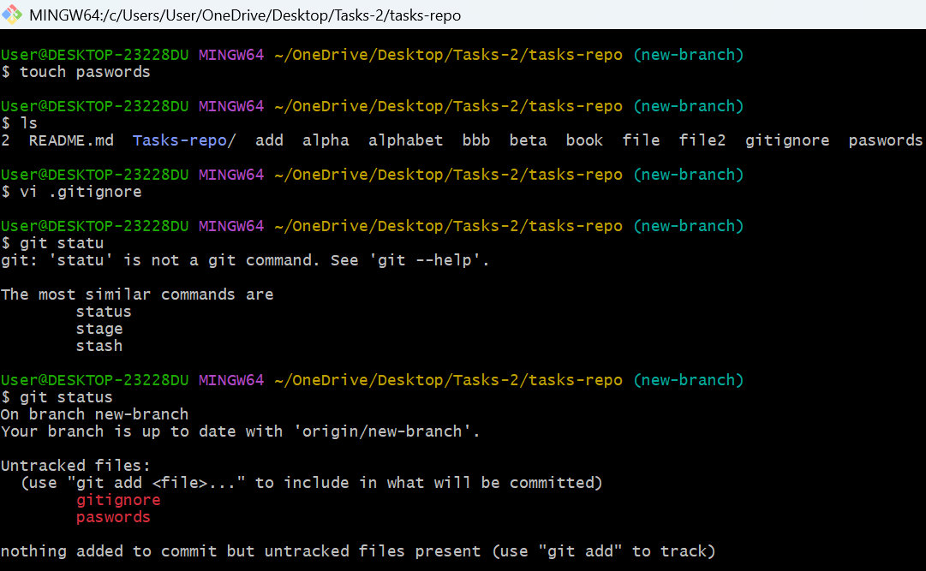

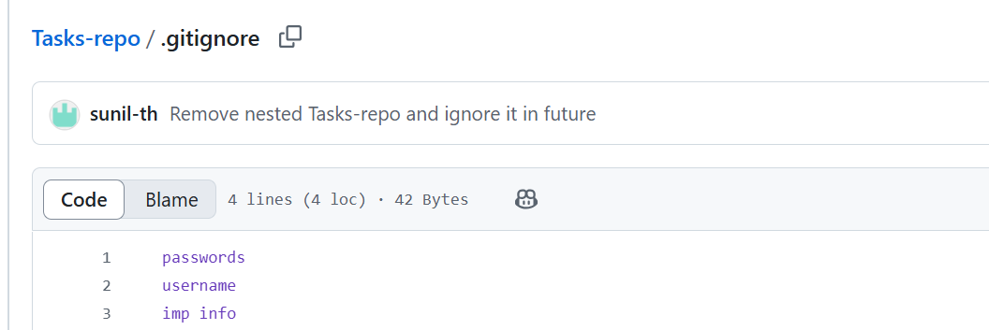

13)make a commit and make that commit reset without savings changes

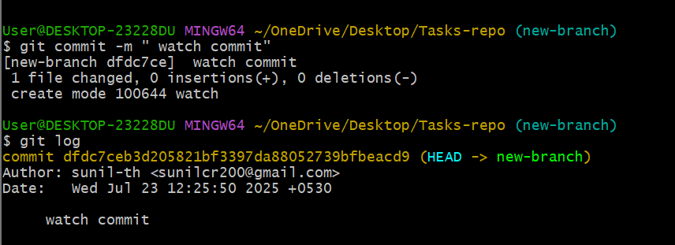

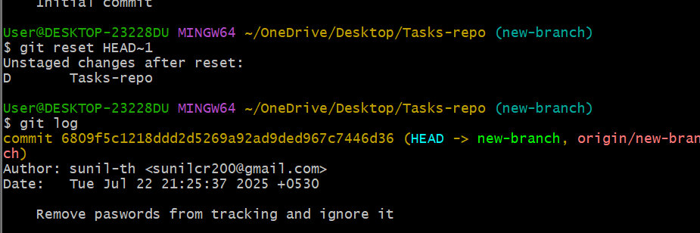

14)Revert a commited commit to the older version.

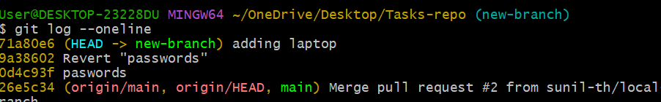

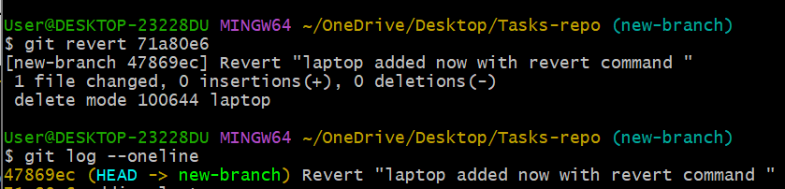

15)push a file to stash without savings the changes and work on another file.

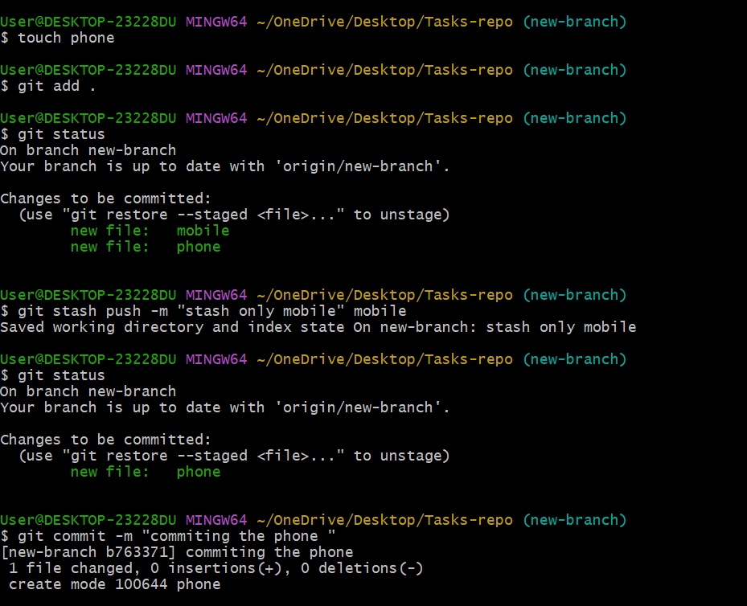

16)undo the stash file and start working on that again.

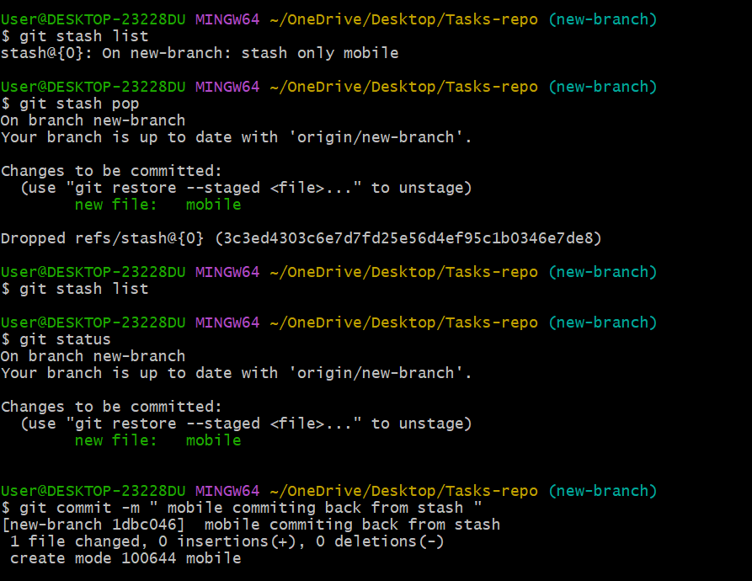

17)generate a ssh-keygen and configure into github.

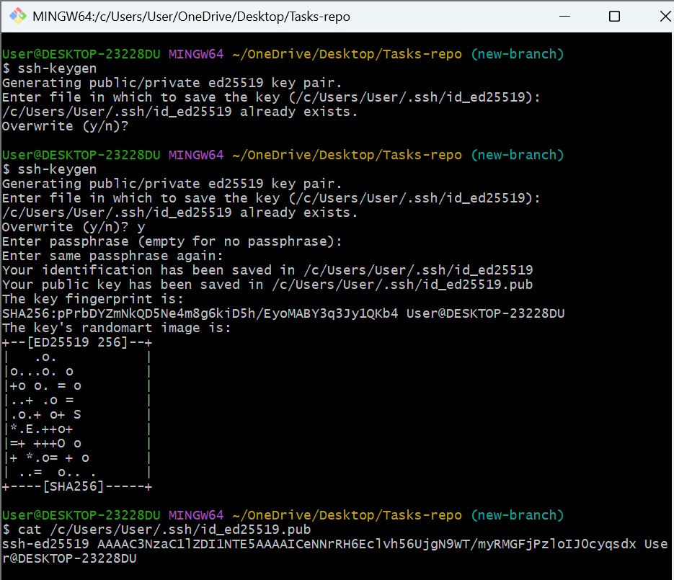

Add the key to GitHub

Go to [GitHub SSH Keys page](https://github.com/settings/ssh/new)

**Key**: Paste the copied public key.

Click **"Add SSH key"**

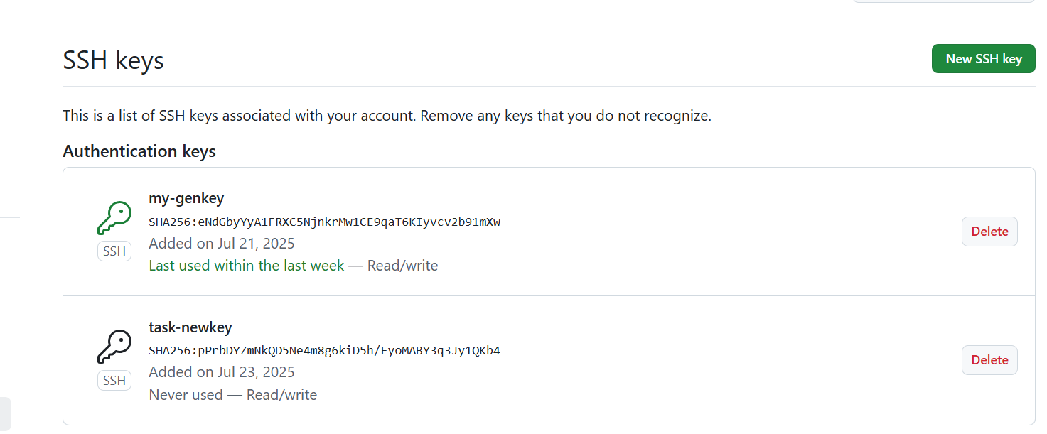

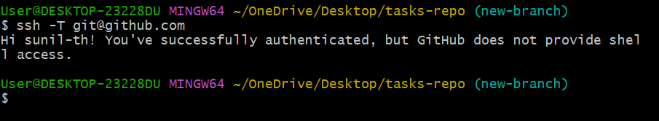

18)configure webhooks to github.

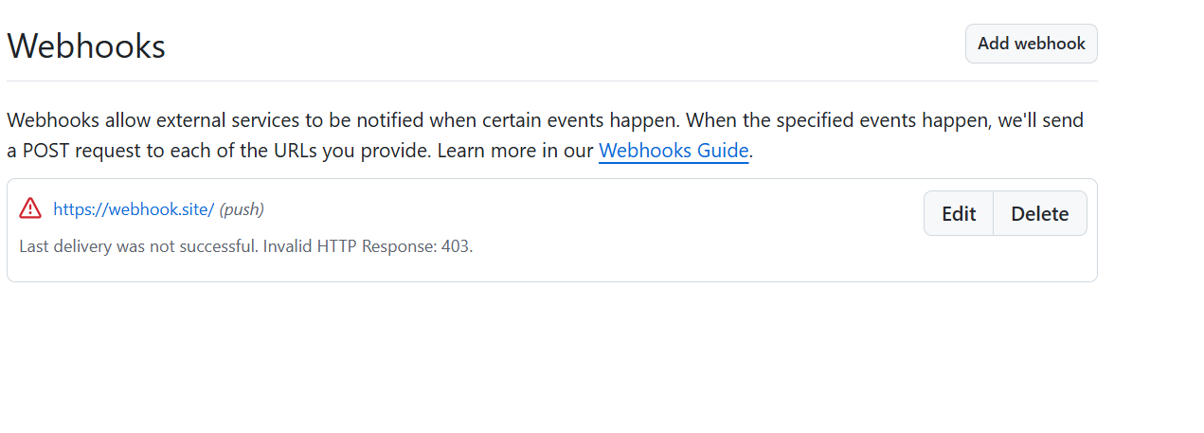

19)basic understanding of .git file.

The .git directory is the **heart of a Git repository**. When you run:

git init

Git creates a hidden .git/ folder inside your project. This folder contains everything Git needs to track changes, branches, history, remotes, and more.

20)Check all the logs of git.

git log

git log --oneline # One-line per commit

git log --graph # Shows branches and merges

git log --all # Shows commits from all branches

git log --stat # Shows file-level changes in each commit

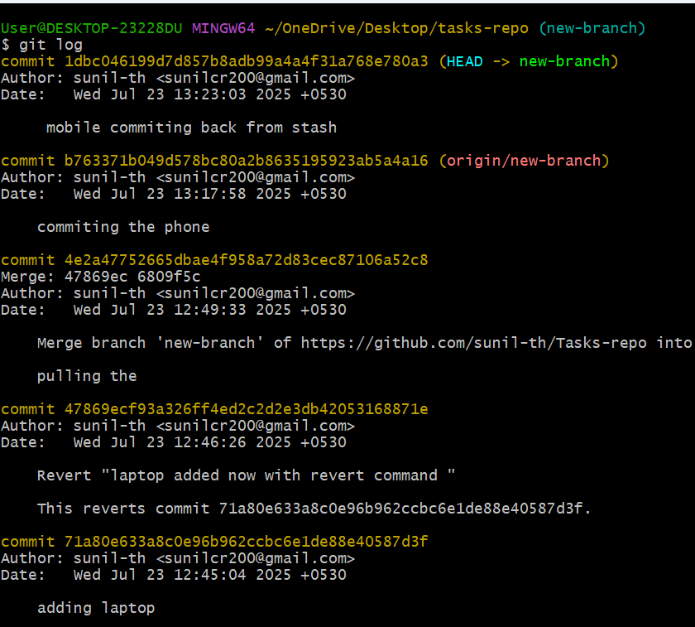

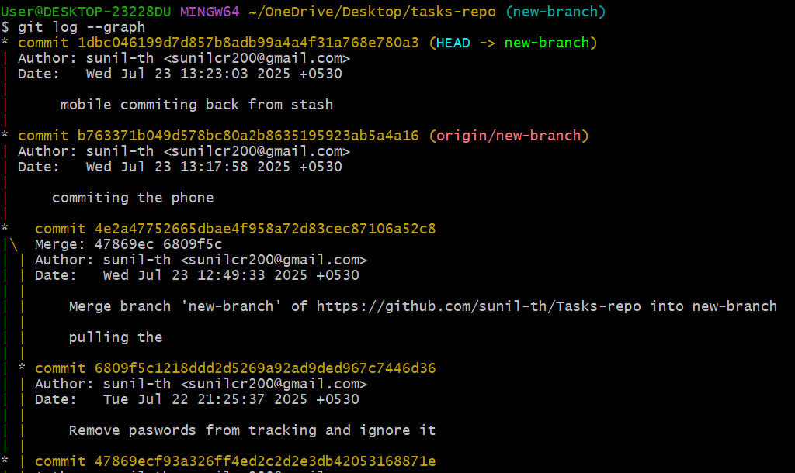

21)Rename the commit message.

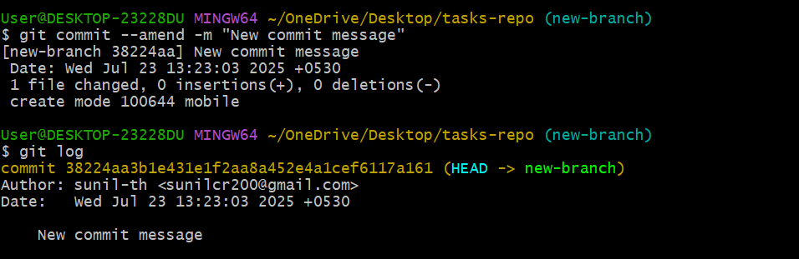

22)Merge multiple commits into single commit.

